USING PASTE FROM CATALOG

Placing 480VAC DISCONNECT SWITCH

1. select Edit> Paste from Catalog

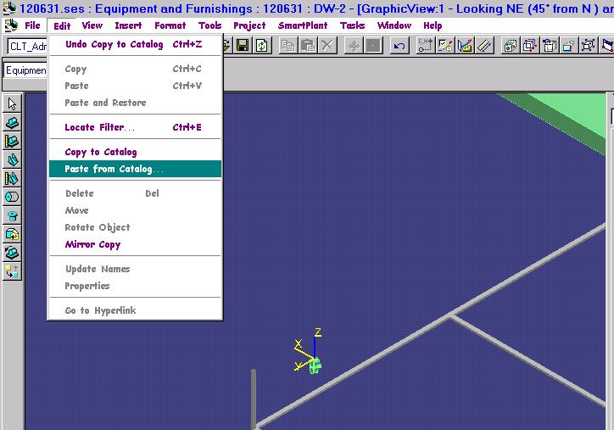

2. Expand module Equipment> Electrical
3. Select 480VAC DISCONNECT SWITCH and OK
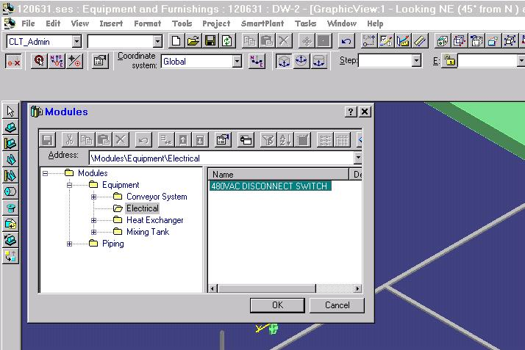

4. In the workspace explorer select the system folder where the new item will belong, eg. RP Electrical Eqp and OK
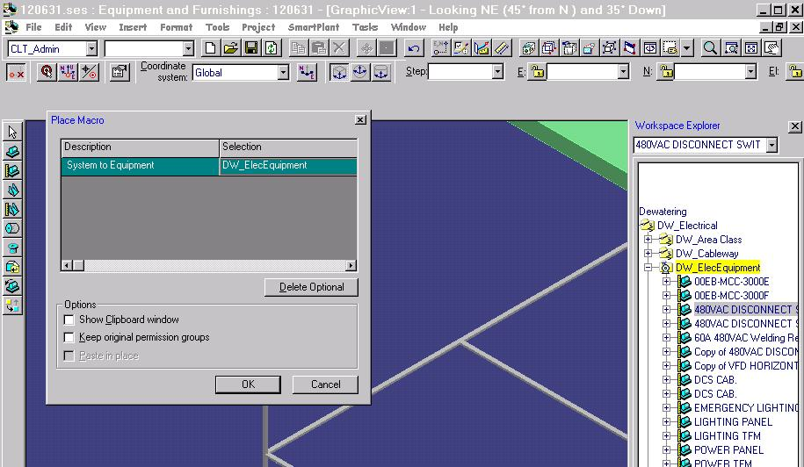

5. Use pinpoint as needed to establish the location of the new switch
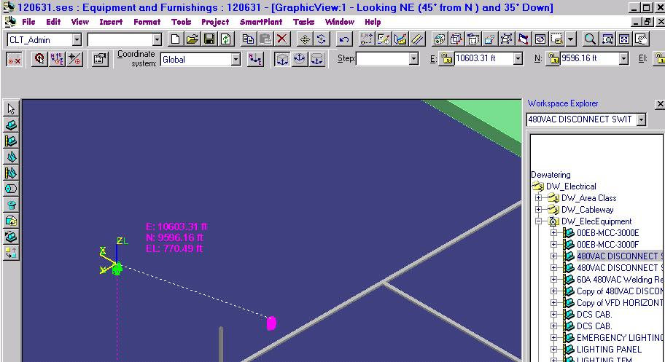

6. Once placed, revise the equipment Name attribute to remove “Copy of”. You can enter a unique identifier or allow for the exact same eqp Name as the source item.
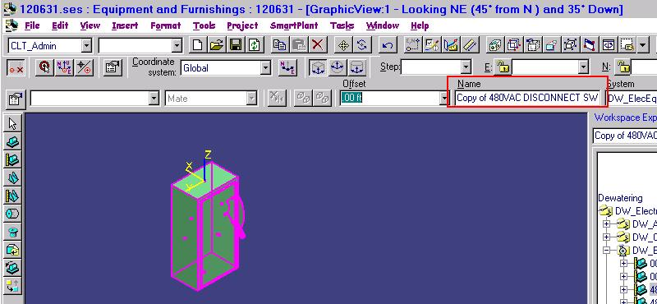

DONE.

